Design and Analysis of Algorithms
Homework 1 Solutions
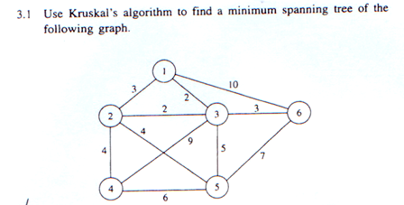
Ans: Total weight = 2+2+3+4+4 = 15

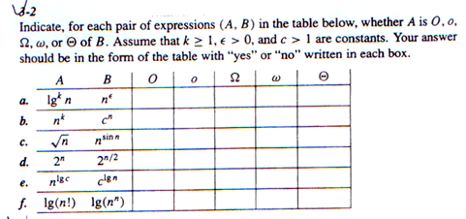
Ans:
Y | Y | N | N | N
Y | Y | N | N | N
N | N | N | N | N
N | N | Y | Y | N
Y | N | Y | N | Y
Y | N | Y | N | Y

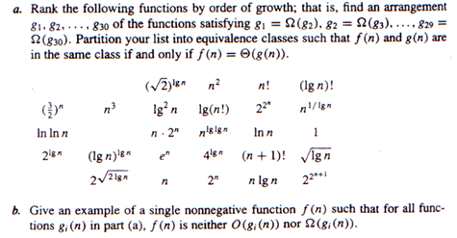
Ans: (a) $2^{2^{n+1}}>2^{2^{n}}>\left(n+1\right)!>n!>e^{n}>n*2^{n}>2^{n}>{\left(\frac{3}{2}\right)}^{n}$
$$>\left[n^{lglgn}={lgn}^{lgn}\right]>\left(lgn\right)!>n^{3}>\left[4^{lgn}=n^{2}\right]>\left[n*lgn=\lg\left(n!\right)\right]$$
$$>\left[2^{lgn}=n\right]>{\left(\sqrt{2}\right)}^{lgn}>2^{\sqrt{2lgn}}>\lg^{2}n>lnn>\sqrt{lgn}>lnlnn>[n^{\frac{1}{lgn}}=1]$$
(b) f(n) = $n^{\sin{n}}$
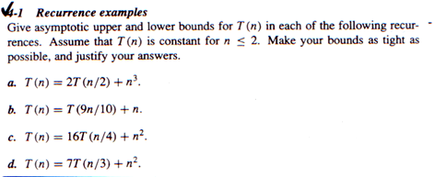
Ans: (a) T(n) = Θ($n^{3}$)
(b) T(n) = Θ(n)
(c) T(n) = Θ($n^{2}lgn$)
(d) T(n) = Θ($n^{2})$

